Saturday, January 19, 2019

CHAPTER 13

P.P. 13.1 For mesh 1,

141.42+j141.42 = 4(1 + j2)I₁ + jI₂ (1)

For mesh 2, 0 = jI₁ + (10 + j5)I₂ (2)

For the matrix form

Δ = j100, Δ₂ = 141.42–j141.42

I₂ = Δ₂/Δ = (141.42–j141.42)/j100

V_{o} = 10I₂ = 10(–1.4142–j1.4142) = 20∠–135° V

P.P. 13.2 Since I₁ enters the coil with reactance 2Ω and I₂ enters the coil with reactance 6Ω, the mutual voltage is positive. Hence, for mesh 1,

100∠60º = (5 + j2 + j6 – j 3x2)I₁ – j6I₂ + j3I₂

or 100∠60º = (5 + j2)I₁ – j3I₂ (1)

For mesh 2, 0 = (j6 – j4)I₂ – j6I₁ + j3I₁

or I₂ = 1.5I₁ (2)

Substituting this into (1), 100∠60º = (5 – j2.5)I₁

I₁ = (100∠60º)/(5.59∠–26.57º) = 17.889∠86.57º A

I₂ = 1.5I₁ = 26.83∠86.57º A

P.P. 13.3 The coupling coefficient is, k = m/ = 0.7071

To obtain the energy stored, we first obtain the frequency-domain circuit shown below.

100cos(ωt) becomes 100∠0º, ω = 2
1H becomes jω1 = j2
2H becomes jω2 = j4
(1/8) F becomes 1/jωC = -j4

j2

j4
+
–

V_{S}

2 Ω

4 Ω

-j4

I₁

I₂

For mesh 1, 100 = (4 – j4 + j4)I₁ – j2I₂

or 50 = 2I₁ – jI₂ (1)

For mesh 2, –j2I₁ + (2 + j2)I₂ = 0

or I₁ = (1 – j)I₂ (2)

Substituting (2) into (1), (2 – j3)I₂ = 50

I₂ = 50/(2 – j3) = 13.87∠56.31º

I₁ = 19.658∠11.31º

In the time domain, i₁ = 19.658cos(2t + 11.31º)
i₂ = 13.87cos(2t + 56.31º)

At t = 1.5, 2t = 3 rad = 171.9º

i₁ = 19.658cos(171.9º + 11.31º) = –19.62 A
i₂ = 13.87cos(171.9º + 56.31º) = –9.25 A

The total energy stored in the coupled inductors is given by,

W = 0.5L₁(i₁)² + 0.5L₂(i₂)² – 0.5M(i₁i₂)
= 0.5(2) (–19.62)² + 0.5(1)(–9.25)² – (1)(–19.62)(–9.25)
= 246.2 J

P.P. 13.4 Z_{in} = 4 + j8 + [3²/(j10 – j6 + 6 + j4)]

= 4 + j8 + 9/(6 + j8)

= 8.58∠58.05º Ω

The current from the voltage is,

I = V/Z = 40∠0º/8.58∠58.05º = 4.662∠–58.05º A

P.P. 13.5 L₁ = 10, L₂ = 4, M = 2

L₁L₂ – M² = 40 – 4 = 36

L_{A} = (L₁L₂ – M²)/(L₂ – M) = 36/(4 – 2) = 18 H

L_{B} = (L₁L₂ – M²)/(L₁ – M) = 36/(10 – 2) = 4.5 H

L_{C} = (L₁L₂ – M²)/M = 36/2 = 18 H

Hence, we get the π equivalent circuit as shown below.

18 H

18 H

4.5 H

P.P. 13.6 If we reverse the direction of I₂ so that we replace I₂ by –I₂, we have the circuit shown in Figure (a).

j6

j3
+
–

12∠0º

12 Ω

-j4

I₁

I₂

j3

(a)

We now replace the coupled coil by the T-equivalent circuit and assume ω = 1.

L_{a} = 5 – 3 = 2 H

L_{b} = 6 – 3 = 3 H

L_{c} = 3 H

Hence the equivalent circuit is shown in Figure (b). We apply mesh analysis.

j3

I₁

I₂
+
–

12∠0º

12 Ω

j3

j2

-j4

(b)

- = i₁(-j4 + j2 + j3) + j3i₂

or 12 = ji₁ + j3i₂ (1)

Loop 2 produces, 0 = j3i₁ + (j3 + j3 + 12)i₂

or i₁ = (-2 + j4)i₂ (2)

Substituting (2) into (1), 12 = (-4 + j)i₂, which leads to i₂ = 12/(-4 + j)

I₂ = -i₂ = 12/(4 – j) = 2.91∠14.04º A

I₁ = i₁ = (-2 + j4)i₂ = 12(2 – j4)/(4 – j) = 13∠–49.4º A

P.P. 13.7

(a) n = V₂/V₁ = 110/2200 = 1/20 (a step-down transformer)

(b) S = V₁I₁* = 2200x5 = 11 kVA

(c) I₂ = I₁/n = 5/(1/20) = 100 A

P.P. 13.8 The 16 – j24-ohm impedance can be reflected to the primary resulting in

Z_{in} = 2 + (16 – j24)/16 = 3 – j1.5

I₁ = 240/(3 – j1.5) = 240/(3.354∠–26.57°) = 71.56∠26.57º

I₂ = –I₁/n = –17.89∠26.57º

V_{o} = –j24I₂ = (24∠–90º)(–17.89∠26.57º) = 429.4∠116.57ºV

S₁ = V₁I₁* = (240)( 71.56∠26.57º) = 17.174∠–26.57º kVA.

P.P. 13.9
+
V₁
–

+
V₂
–

8 Ω
+
–

120∠0º

10 Ω

2 Ω

1:2

4 Ω
+ v₀ –

I₂

2

I₁

1
+
V₃
–

Consider the circuit shown above.

At node 1, (120 – V₁)/4 = I₁ + (V₁ – V₃)/8 (1)

At node 2, [(V₁ – V₃)/8] + [(V₂ – V₃)/2] = (V₃)/8 (2)

At the transformer terminals, V₂ = –2V₁ and I₂ = –I₁/2 (3)

But I₂ = (V₂ – V₃)/2 = –I₁/2 which leads to I₁ = (V₃ – V₂)/1 = V₃ + 2V₁.

Substituting all of this into (1) and (2) leads to,

(120 – V₁)/4 = V₃ + 2V₁ + (V₁ – V₃)/8 which leads 240 = 19V₁ + 7V₃ (4)

[(V₁ – V₃)/8] + [(–2V₁ – V₃)/2] = V₃/8 which leads to
V₃ = –7V₁/6 (5)

From (4) and (5),

240 = 10.833V₁ or V₁ = 22.155 volts

V₃ = –7V₁/6 = –25.85 volts

V_{o} = V₁ – V₃ = 48 V

P.P. 13.10 We should note that the current and voltage of each winding of the autotransformer in Figure (b) are the same for the two-winding transformer in Figure (a).

+
120V
–

+
10V
–

6 A

(a)

0.5A

(b)
+
10V
–

+

130V

–

+
120V
–

+
120V
–

0.5A

3A

6.5A

For the two-winding transformer,

S₁ = 120x0.5 = 60 VA

S₂ = 6(10) = 60 VA

For the autotransformer,

S₁ = 120(6.5) = 780 VA

S₂ = 130(6) = 780 VA

P.P. 13.11 (I₂)* = S₂/V₂ = 16,000/1000 = 16 A

Since S₁ = V₁(I₁)* = V₂(I₂)* = S₂, V₂/V₁ = I₁/I₂, 1000/2500 = I₁/32,

or I₁ = 1000x16/2500 = 6.4 A.

At the top, KCL produces I₁ + I_{o} = I₂, or I_{o} = I₂ – I₁ = 16 – 6.4 = 9.6 A.

P.P. 13.12

- S_{T} = (√3)V_{L}I_{L}, but S_{T} = P_{T}/cosθ = 40x10⁶/0.85 = 47.0588 MVA

I_{LS} = S_{T}/(√3)V_{LS} = 47.0588x10⁶/[(√3)12.5x10³] = 2.174 kA

(b) V_{LS} = 12.5 kV, V_{LP} = 625 kV, n = V_{LS}/V_{LP} = 12.5/625 = 0.02

(c) I_{LP} = nI_{LS} = 0.02x2173.6 = 43.47 A

or I_{LP} = S_{T}/[(√3)v_{LP}] = 47.0588x10⁶/[(√3)625x10³] = 43.47 A

(d) The load carried by each transformer is (1/3)S_{T} = 15.69 MVA

P.P. 13.13 The process is essentially the same as in Example 13.13. We are given the coupling coefficient, k = 0.4, and can determine the operating frequency from the value of ω = 4 which implies that f = 4/(2π) = 0.6366 Hz.

ACMAG=160V
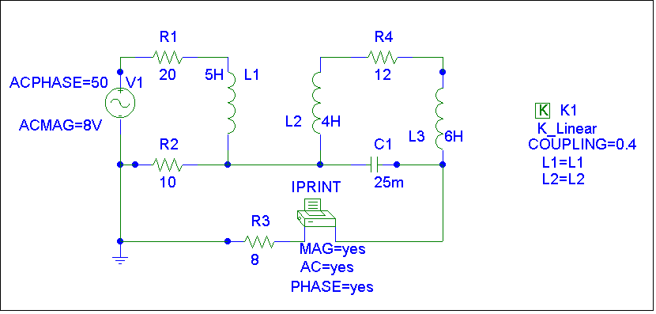

Saving and then simulating produces,

i_{o} = 2.012 cos(4t + 68.52º) A

P.P. 13.14 Following the same basic steps in Example 13.14, we first assume ω = 1. This then leads to following determination of values for the inductor and the capacitor.

j15 = jωL leads to L = 15 H

-j16 = 1/(ωC) leads to C = 62.5 mF

The schematic is shown below.
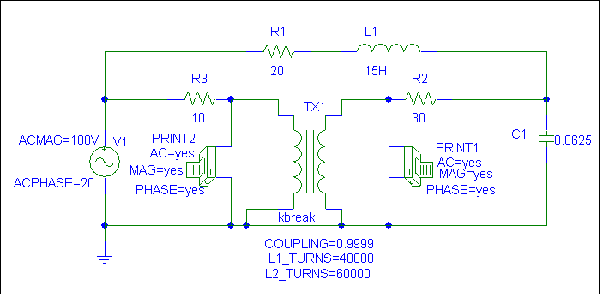

ACMAG=220V

FREQ VM($N_0005,0) VP($N_0005,0)

1.592E-01 1.530E+02 2.185E+00

FREQ VM($N_0001,0) VP($N_0001,0)

1.592E-01 2.302E+02 2.091E+00

Thus,

V₁ = 153∠2.18° V

V₂ = 230.2∠2.09° V

Note, if we divide V₂ by V₁ we get 1.5046∠–.09˚ which is in good agreement that the transformer is ideal with a voltage ratio of 1:1.5 (or 2:3)!

P.P. 13.15 V₂/V₁ = 13,200/120 = 110

P.P. 13.16
+
–

V_{S}

Z_{L}/n²
+
V₁
–

Z₁

As in Example 13.16, n² = Z_{L}/Z₁ = 400/(2.5x10³) = 4/25, n = 0.4

By voltage division, V₁ = V_{s}/2 (since Z₁ = Z_{L}/n²), therefore V₁ = 60/2 = 30 volts, and

V₂ = nV₁ = (0.4)(30) = 12 V

P.P. 13.17

(a) S = 12x60 + 350 + 4,500 = 5.57 kW

(b) I_{P} = S/V_{P} 5570/2400 = 2.321 A

